USEFUL EQUATIONS

Child-Pugh score:
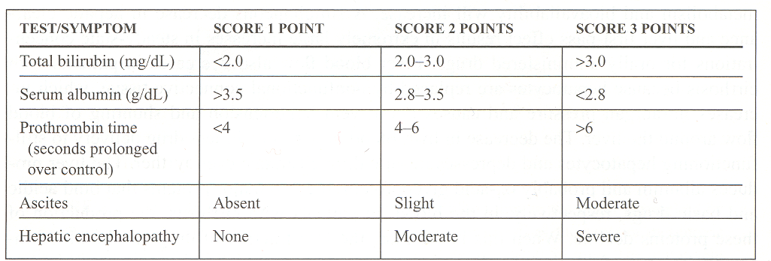

CL_{H}= LBF * (f_{u} * Cl _{int})
LBF + (f_{u} * Cl _{int})

Low hepatic extraction ratio drugs:
Css (total) = Dose Css(free) = Dose or f_{u} * Css(total)
Cl_{H} Cl _{int}

High hepatic extraction ratio drugs:
Css (total) = Dose Css(free) = f_{u} * Css(total) or f_{u} * dose
Cl_{H} LBF

Ke = 0.00293 (CrCL) + 0.014 (gentamicin, tobramycin, amikacin)

Ke = 0.00083 (CrCL) + 0.0044 (vancomycin)

Vd = 0.25 L/kg (gentamicin, tobramycin, amikacin)

Vd = 0.7 L/kg (vancomycin)

Dialysis:
Ke off = 0.021/hr (aminoglycosides)

Ke on = 0.178/hr (aminoglycosides)

Supplemental Dose = V_{D} x (C_{desired} – C_{post-HD})

C₂ = C₁ x e ^{–Ke x t} OR ln (C₁/ C₂) = Ke
t
T_{1/2} = 0.693
Ke

Ke = Cl / Vd

LD = C _{desired} x Vd
F S

τ = ln (Cmax desired / Cmin desired) + t’ t’ = infusion time (hr)
Ke

MD = Css (Cl) (τ)
SF

R₀ = Css (Cl)
S

R₀ = (Ke) (Vd) (Cmax desired) x (1-e ^{-Ke x} τ)
(1-e ^{-Ke x t’})

C_{peak} = R_{O} x (1-e ^{-Ke x t’}) R_{O} = infusion rate; also the
(Ke)(Vd)(1-e ^{-Ke x τ}) maintenance dose, in
milligrams per hour

C_{trough} = C_{peak} x (e ^{–Ke (τ– t’)})

Vd = R_{O} x (1 – e ^{–Ke x t’})
Ke (C_{extrap. peak} – C_{extrap. trough})

Phenytoin :

Clearance = Vmax / (Km + C)

MD = (Vmax * Css) / S (Km + Css)

Mini Load = (Vd)(Css desired – Css initial) / (S)(F)

Css_{new} = (D_{new}/D_{old})Css_{old}

Adjusted Phenytoin Concentration = Concentration observed / [(0.2 * albumin) + 0.1]

Adjusted Phenytoin Concentration = Concentration observed / [(0.1 * albumin) + 0.1]

Adjusted weight = IBW + (1.33) (TBW – IBW)

Phenytoin Vd = 0.7 L/kg

Phenytoin Vmax = 7 mg/kg/day

Phenytoin Km = 4 mg/L

F=1

S= 0.92 for capsules and injectable preparations
S= 1 for suspension and chewable tablets

Lithium:
Maintenance: Cl = 0.288 x (Crcl)

Acute mania: Cl = 0.432 x (Crcl)

D_{new}/C_{ss,new} = D_{old}/C_{ss,old}

300 mg lithium carbonate = 8.12 mmol Li⁺

Lidocaine:
S = 0.87
V_{i} = 0.5 L/kg (CHF 0.3 L/kg, liver disease 0.61 L/kg)
V_{d} = 1.3 L/kg (CHF 0.88 L/kg, liver disease 2.3 L/kg)
Cl = 10 mL/kg/min (CHF 6 mL/kg/min, cirrhosis 6 mL/kg/min)

Amiodarone: F = 0.5
V_{d} = 60 L/kg

Manufacturer IV dosing recommendations: 1 mg/min x 6 hours then 0.5 mg/min x 18hrs
Thereafter can continue 0.5mg/min for up to 3 weeks if necessary

Digoxin: F=0.7 (tablets), 0.8 (elixir)
S = 1
Vd= 7L/kg
Vd in renal failure =
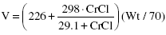

Cl= 1.3(CrCl) + 40ml/min
Cl in CHF= 1.3 (CrCl) + 20 ml/min

Theophylline: F= 100% for theophylline
S= 1 for theophylline,
S= 0.8 for aminophylline
Vd= 0.5 L/kg
Cl = 0.04 L/kg/hr

Disease state/condition | Half-life
Adult, normal organ function | 8 hours
Tobacco or marijuana smoker | 5 hours
Mild heart failure (Class I and II) | 12 hours
Moderate to severe heart failure (Class III and IV) | 24 hours
Hepatic disease (cirrhosis or acute hepatitis) | 24 hours
Elderly, > 65 years | 12 hours
Hartford Nomogram:
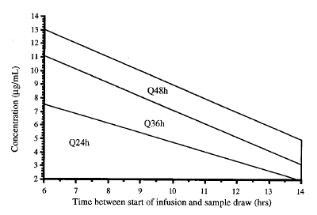

Initial dosing interval using the Hartford nomogram

CREATININE CLEARANCE (mL/min) | DOSING INTERVAL (hr)
> 60 | 24
40-59 | 36
20-39 | 48
<20 | Dose when concentration is < 1-2 mcg/mL

